# Literature Review

***Cloud computing for building effective information systems in (the financial services sector) (or Sport), for example***

* Learn how to use Mendeley
* Start planning literature review based on the chosen topic from the list provided in Unit 1. The outline of the literature review can be submitted for formative feedback in Unit 4 before final submission in Unit 7.

1. Create a Research Territory Map (RTM)
2. Perform Literature Search on the topic
   1. Find relevant material
      1. Search the Internet using keywords (e.g. “cloud computing” AND “information systems” AND “financial services”)
      2. Find any books
      3. Search Google Scholar
      4. Web of Science
      5. Springer
      6. ScienceDirect
3. Record good sources in a spreadsheet
4. Download documents in a folder
5. Evaluate material. Read Abstracts, Scan citations and update spreadsheet
6. Create / Update bibliography
7. Find a gap in the field
8. Define a question
9. Repeat from step 1 until happy
10. Decide on structure (Chronological / Thematic / Methodological / Theoretical
11. **Perform Literature Review**
    1. **Introduction**
    2. **Main Body**
       1. **How cloud computing can be used to build effective information systems for financial services**
       2. **The area of study**
       3. **Discussion recent and current developments in the field**
       4. **Highlight any limitations in the field**
    3. **Conclusion**

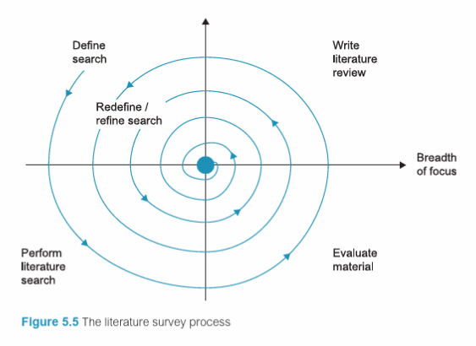

**Deliverables** **for a stand-alone paper:**

I plan to:

1. Summarise major findings and implications
2. Make suggestions for future research

I will refer to the guide questions from unit 2 to evaluate and refine your literature review before submission, bearing in mind the key aims of a **standalone literature review.**

* To provide an overview of current knowledge on the chosen topic
* To demonstrate an awareness of relevant, current literature
* To highlight similar and contrasting views on my chosen topic
* To showcase my research and writing skills

I will write the literature review using the following questions as a framework to guide me:

|  |
| --- |
| * **WRITING A LITERATURE REVIEW** * **Guiding questions to support planning, revising, and refining of a *literature review \**** |

|  |  |
| --- | --- |
| 1. | **What is the focus and aim of your review? Who is your audience?**  To explore the benefits to adopting cloud computing to build effective information systems in sport  To explore the different ways in which it can be used  The audience is anyone in sport who may not have moved data to the cloud and whoever else has a passing interest in the topic. |
| 2. | **Why is there a need for your review? Why is it significant?**  This is significant as it can help others with a greater cohesion of understanding of the cloud’s possibilities in furthering the sport industry. |
| 3. | **What is the context of the topic or issue? What perspective do you take? What framework do you use to synthesise the literature?** |
| 4. | **How did you locate and select sources for inclusion in the review?**  Internet, Google Scholar |
| 5. | **How is your review structured?** |
| 6. | **What are the main findings in the literature on this topic?** |
| 7. | **What are the main strengths and limitations of this literature?** |
| 8. | **Are there any discrepancies in this literature?** |
| 9. | **What conclusions do your draw from the review? What do you argue needs to be done as an outcome of the review?** |

* As with other sets of guiding questions in this book, select those questions that are relevant to your context, add others as appropriate, and decide the order in which you will address them to communicate effectively with your audience.

*Source*: Healey, M., Matthews, K., & Cook-Sather, A. (2020) *Writing about learning and teaching in higher education: Creating and contributing to scholarly conversations**across a range of genres*. Center for Engaged Learning Open-Access Books, Elon University. 142-152.